Interaction Design: Usability

1.) Introduction

Hi guys! Welcome to [Design Fundamentals], a Tuts+ premium course. I’m [Sarah Kahn] and today we’re going to [talk about Usability and User Interface Design].

Getting started

So, in our last lesson, Design Fundamentals Introduction to Interaction Design, we established why you want to make your websites usable. Odds are you’re already sold on the idea, or you wouldn’t be listening today. But how to get started? Getting started with usability can be a bit like trying to start jumping rope when the rope is already swinging. We’ve all been there.



I’m going to give you some practical steps that you can start using immediately to make your websites and web applications more user-friendly. It’s not magic, I promise, but it does take some good old fashioned elbow grease.

Here’s what we’re going to cover:

-Metrics and current user research

-planning content for usability

-wireframes and microusability tests

-usability in production

1.) find out who your current users are.

You can’t design a good user experience if you don’t know who your users are. Not only do you not know what they’re expecting from your website, you don’t know their technical or physical limitations, cultural biases, or even what sort of device they’re viewing it on!

So how do we go about finding out this information?

Step 1: gather metrics. Usability designers live and die for data. If you’re starting a brand new project, plan for how you’re going to install metrics reporting as soon as you get up and running. If you’re working on an existing project, get metrics, stat!

My favorite tools to use for ongoing metrics gathering are google analytics, piwik, and kissmetrics. Each metrics tool has its strengths and weaknesses- google analytics is great for overall trend data, but not as strong on gathering information on individual users such as click paths. (If you aren’t familiar, a click path is a list showing where one single user went from start to finish during one visit to a given site.) Google analytics and Piwik are both free to use. Kissmetrics provides a bit more eye candy, but is hosted and not free.

<next slide>

Visual clickdata is a powerful tool to have in your toolbox. My favorite heatmap generating tool is Crazyegg. Crazyegg is not free, but it’s far cheaper than the competition and head and shoulders above in functionality.

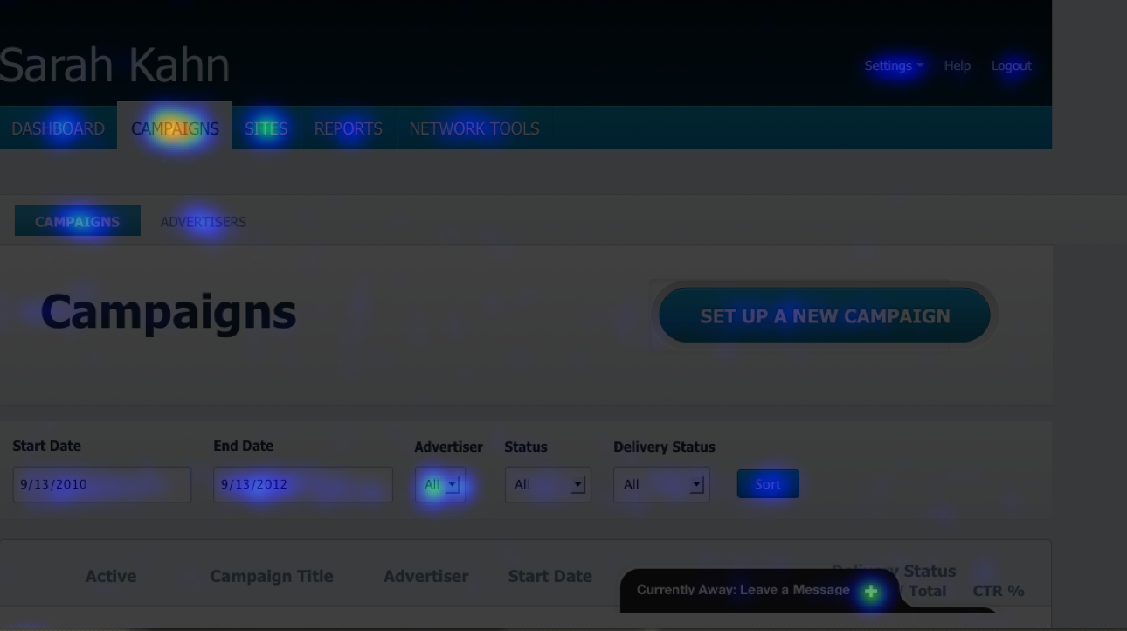

What does all of this data do for you?

Over time, you can get a picture of who your users are. Are they using mobile phones, the latest apple macbook, or trusty Windows XP PCs? How long do they take to navigate through your pages? Where are they coming from?

User surveys

If this is an option for you, take things a step further. Begin to create some user profiles based on your current customers. Ask them what they’re using to access your site, and where they are while they’re doing it.

Tools:

I have conducted user surveys on a range of platforms, ranging from emailing a simple list of questions to posting a note on facebook, to compiling a multi-page survey in survey monkey. The specific tool isn’t important, as long as it makes sense in your context. I used facebook when I needed to discuss the language on a homework help page with middle schoolers. I used survey monkey for a more formal survey of business stakeholders.

Some more typical survey platforms include:

surveymonkey

surveygizmo

googledocs

But that said, use the tool that fits the situation. what matters is reaching your users where ever they may be found.

2.) Planning content for usability

So you’ve been gathering all of this data and you’re ready to start rolling out some new features. Or you’re planning a website redesign. How do you apply your findings?

Step 1: Develop user personas



All of that data gathering will help you come up with 3 or 4 typical hypothetical users. Give them names, ages, occupations. Come up with a brief story about their background, and what they expect out of your website. Then, post them on a wall in your office. This helps you to be always mindful of who you’re doing this for. When proposing a color, layout, or feature, ask yourself, ‘What would Fred think about this?’

‘Fred’ can also be an excellent tie-breaker between disagreeing colleagues.

Step 2: Create a sitemap.

It doesn’t matter if it’s high or low tech, but do create a list of all the pages or content sections that will appear in your website or application.

Tools:

My favorite mapping tool is gliffy.com. They offer a limited free edition, but do charge for more than 3 projects.

Other tools commonly used for this are omnigraffle and microsoft visio, neither one is free however.

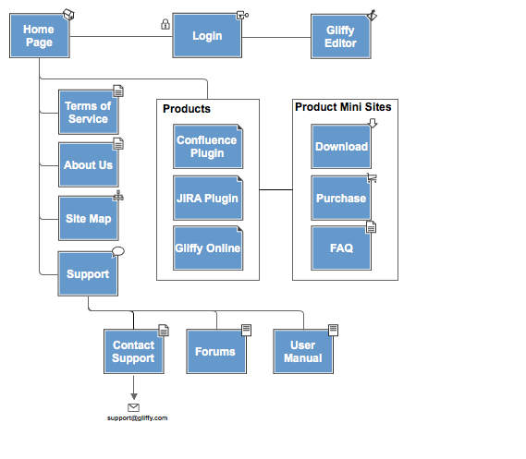

Step 3: Create user flows

My personal favorite way to begin is to take a stack of index cards or sticky notes, and write the name of each page on one each. That way, you can lay them out on a conference table or on the floor, and move them around easily. Figure out how you expect users to interact with the pages- which one will happen first, second, and third? What happens if they make a mistake? What defines a successful visit to your website?

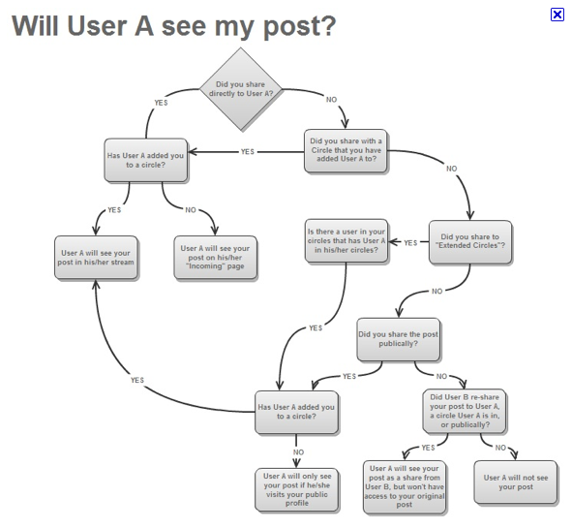

Step 4: Now that you’ve got your content and interactions pretty well nailed down, it’s time to design. Always begin with wireframes.

Wireframes allow you figure out the best placement for your content without getting into the emotional quagmire that can be graphic design. Stakeholders are seldom emotional or opinionated about a pencil sketch.

With wireframes, the more lo-fi the better, to start with. Once you’ve committed something to pixels, you may find you’re more reluctant to move things around.

Tools:

I always begin with pencil and paper. UI stencils has a delightful stencil set with browser sketchpad that’s great for getting ideas rolling. Sticky notes are also your friend- put content pieces on sticky notes and then move them around the paper wireframe to see how they work.

http://www.uistencils.com/

Bonus points if you’re wearing your UX/UI tshirt while you’re doing this:



The wireframing stage is an excellent time to start getting user input. Remember, test early, test often.

If you have users readily available, show them your paper wireframes. Give them a pencil and ask them to touch the pencil to the wireframe to indicate where they would click. You would be amazed at how many potential disasters can be averted by early wireframe testing.

If you’re more into digital wireframes, there are several ways to solicit light, quick feedback- my go-to tool is usabilla.com. I often post a wireframe there and then distribute the link to my users via twitter. The whole exercise takes all of an afternoon, and provides invaluable insights into my proposed design.

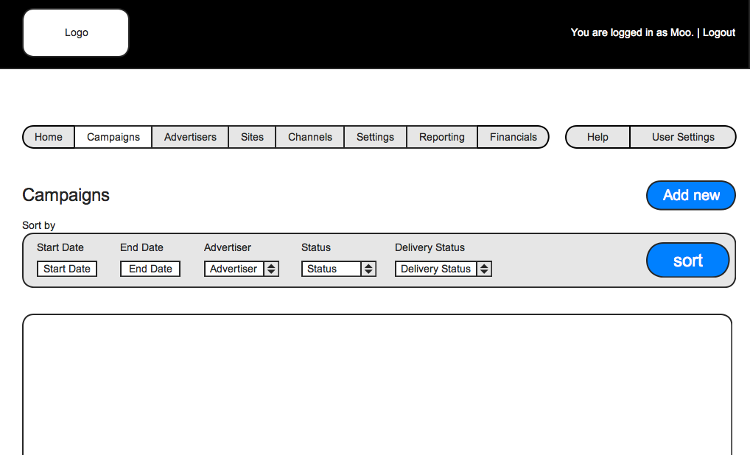

Tools:

For wireframing:

mockingbird

balsamiq

adobe fireworks/photoshop

the gimp

For micro-usability testing:

usabilla

trymyui

[usertesting.com](http://usertesting.com)

Step 5: The visual design.

Now, and only now, are we ready to begin the visual design of the site or feature. Having gathered feedback, decided on content and workflow, and talked with users about the structure and interaction, we may safely begin adding colors and graphics. You might find at this point that having done all of this preparatory work, the design process will go much easier!

Some good places to get feedback on a visual mockup include:

Forrst

ConceptFeedback

At this step, as with all steps, we still will want user feedback. Colors and fonts are something that can have a huge impact on usability. Be mindful of: color blindness, dyslexia, and technical capabilities of user devices when selecting a color palette. It’s always a good idea to test colors on vischeck: http://www.vischeck.com/vischeck/. Also keep in mind that folks with dyslexia rely on word shapes to decipher what they say, so all-caps is a bad idea.

Once you have a working mockup or beta version, go ahead and run it through the user-testing tools again:

usabilla

trymyui

[usertesting.com](http://usertesting.com)

the feedback you’ll get at this point will be completely different than what you got earlier. Also continue to talk to your current users and stakeholders.

Usability In Production.

Rinse, and repeat! If you’ve followed my advice, your metrics will be ticking away on your new site, so continue to check in on them on a regular basis to see how you’re doing.

Remember- users change over time. It’s important to always be Testing.

Communication is also key- ask your users what they think, whether your website is new or you’ve just introduced changes. It’s human nature to want to give an opinion, so the important thing to remember as a user interface designer is to be quiet and LISTEN.

So now that I’ve given you some tools to start with, let’s go play around with some of this stuff.

Assignment:

1.) check into your metrics situation. Do you have any running? If so, login and have a look to familiarize yourself.

2.) Create a simple sitemap with 3 basic user flows. The site doesn’t need to have more than 4-5 pages, this is just to familiarize yourself with the process.

3.) Create a simple pencil and paper mockup.

Next time on [Design Fundamentals], we’re going to cover [Interaction Design: Goals and Feedback]. This is [Sarah Kahn], and from all of us here at Tuts+, thanks for listening!